Results

From the questionnaire designed to find out the need and impact of the Implementation of an Automated Point Management System in FAST Karachi, we received sixty-four responses. Those responses were provided us with insights that how the individuals are dealing with the current paper-based system of Points and whether they want a change in the system.

The findings of the research are defined below:

1. **The convenience of Point Services as compared to Public Transport**

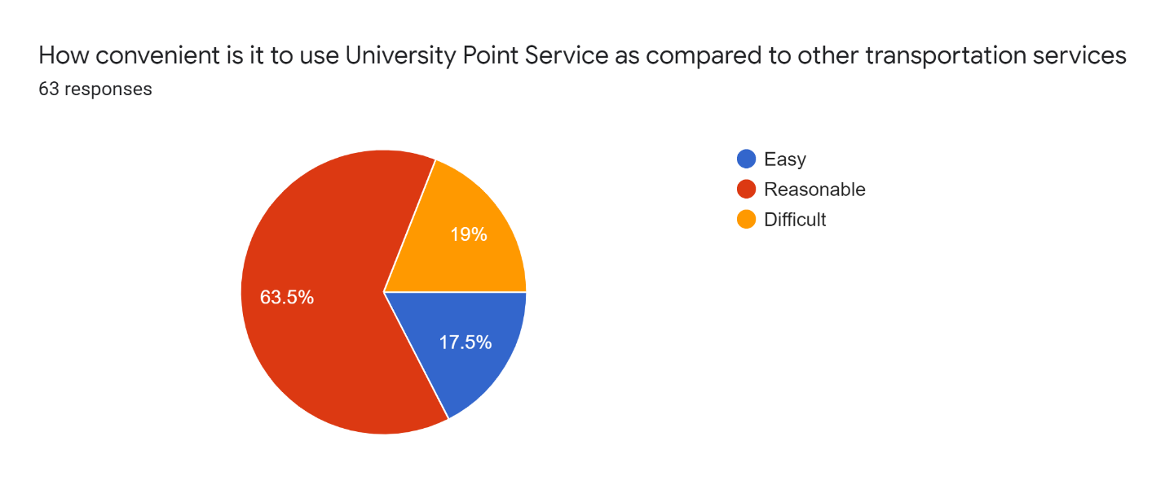

As defined in the chart that 63.5% of the individuals found it reasonable to use University Point Service than to avail Public Transport due to the punctuality and safety of University Point Services. While 19% of the individuals find it difficult and with a sample of 17.5% of the total individuals who took part in the survey it is declared easy.

1. **Need of an Online Point Management System**

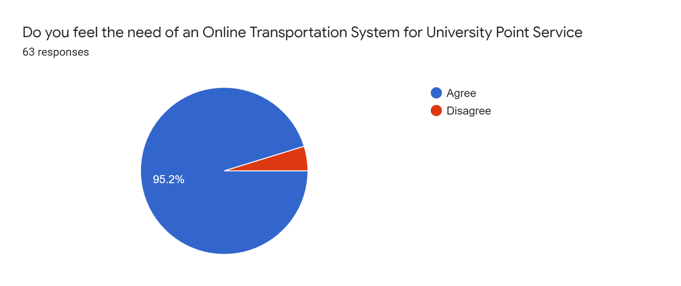

When asked regarding the need for an Automated Point Management System, 95.2% of the total individuals agreed to it making it quite accurate that Automation is necessary for Point Management Services. Meanwhile, a small number of people found themselves satisfied with the current paper-based system.

1. **Need of real-time information of Routes of Points**

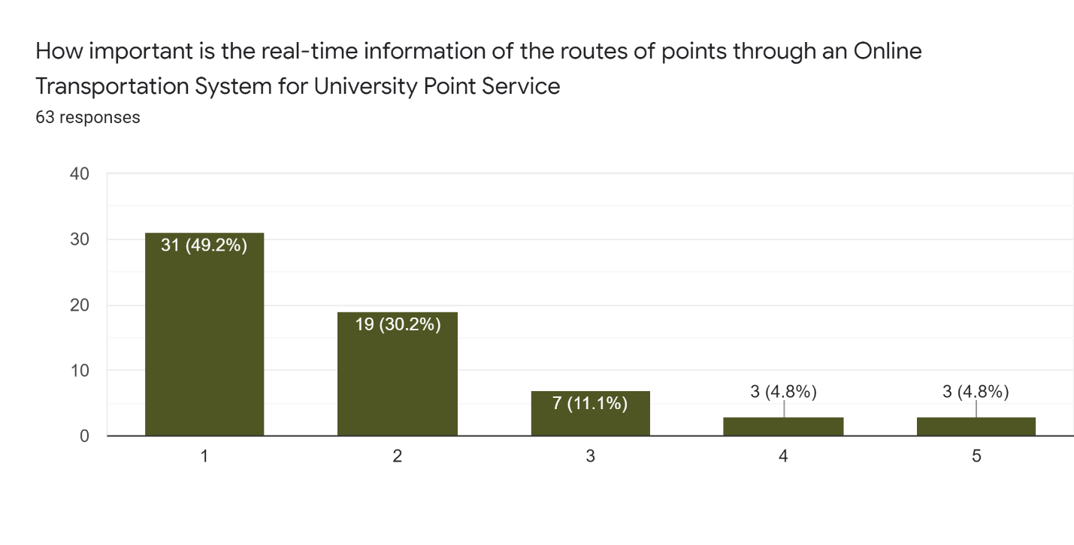

It is evident from the results of the research that the majority of the individuals found it necessary to have real-time information of the daily routes of the specific point they are travelling in at the moment. Whereas, only 3 individuals found it unnecessary to have this information.

1. **Need of real-time information of Vehicles used as Points**

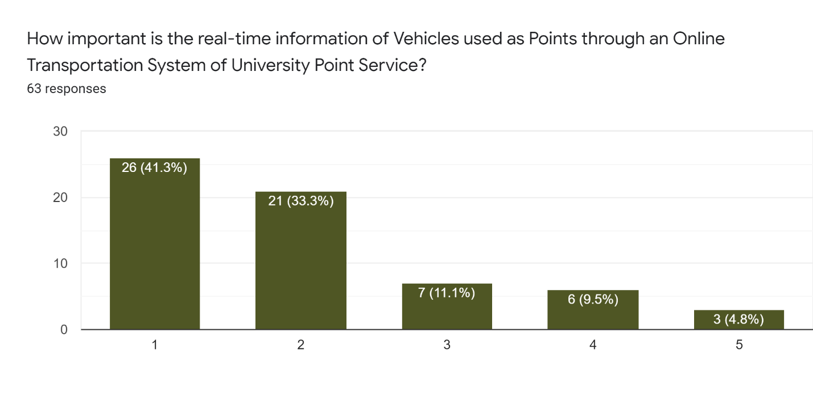

For the real-time information of Vehicles used as Points, the majority of individuals marked it extremely important to have that facility in the Point Management System to be aware of the details of the vehicle they are travelling in.

1. **Need of real-time information of Drivers of Points**

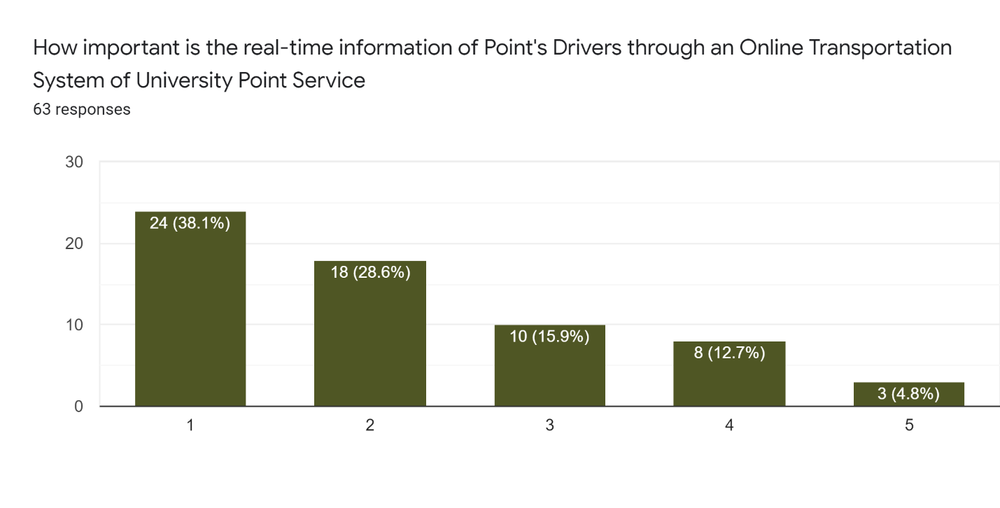

The majority of the individuals who participated in the survey marked it extremely important to have the information of driver(s) they are travelling with to be more secure and safe.

1. **Need of real-time tracking of Points through GPS**

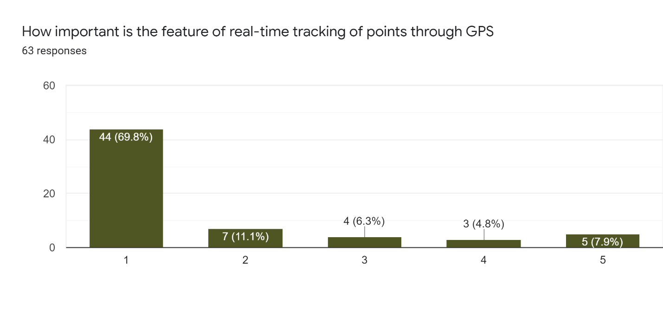

According to the research, 44 out of the 64 individuals found it important to have the real-time location information of Points through GPS Sensor that makes it a majority with 69.8% of the total participants who took part in the research.

1. **Satisfaction with the current paper-based registration system of Point Service**

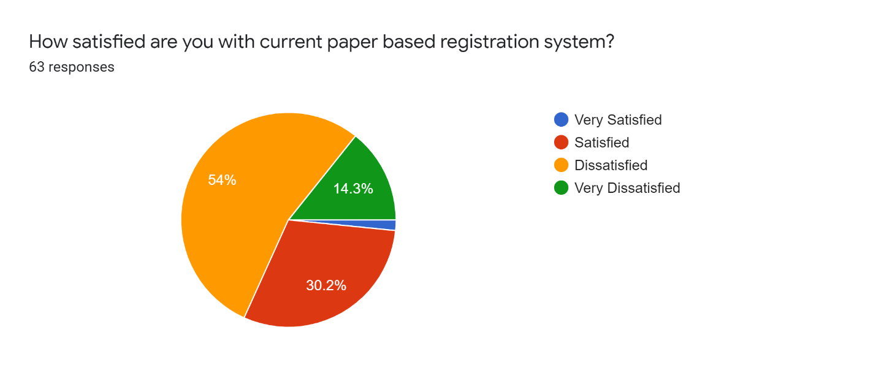

It is visible in the chart that the majority of the individuals are dissatisfied with the current paper-based registration system of points with a percentage of 54% dissatisfied and 14.3% very dissatisfied individuals collectively providing shreds of evidence that the current system is not even satisfactory in terms of its operations.

1. **Need of Online Registration of Point Service**

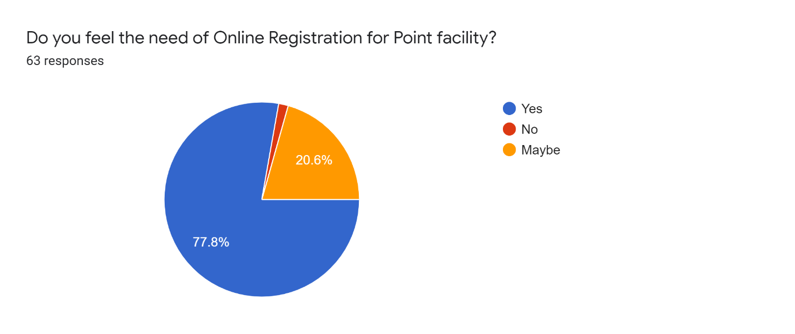

A large number of participants with a percentage of 77.8% of the total participants for this research survey indicated that they are in utmost need of an Online Registration System as compared to the current Paper-Based Registration System for Point Service in the university.

1. **Need of E-Billing System to Pay Point Service Charge**

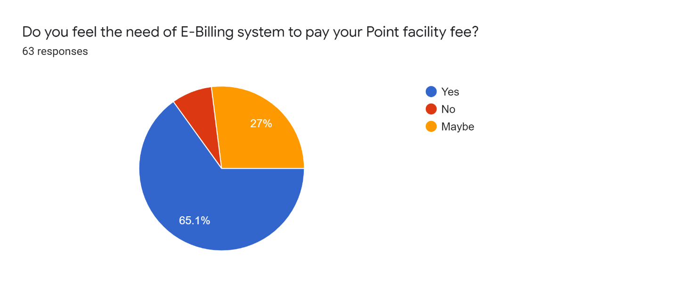

The need for the e-billing facility in the implementation of an automated point management system was supported by the majority of the individuals that took part in the research survey. The votes in favour of this feature were 65.1% and on the second spot, 27% of individuals voted for maybe and, rest for no proving that there is an utmost need for the installation of the e-billing facility.

1. **Need of Intelligent Point Management System by using Safety and Security Sensors**

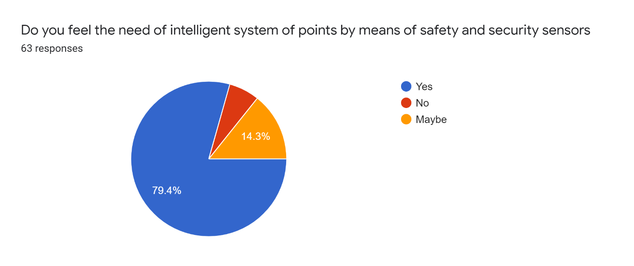

The need for Intelligent System of Point Services utilizing using safety and security sensors was supported by 79.4% of the individuals who answered yes. On the other hand, 14.3% of the individuals were unsure by answering maybe and, rest of the individuals marked no for this question making it a majority supported need by 50 out of 64 individuals.

Conclusion

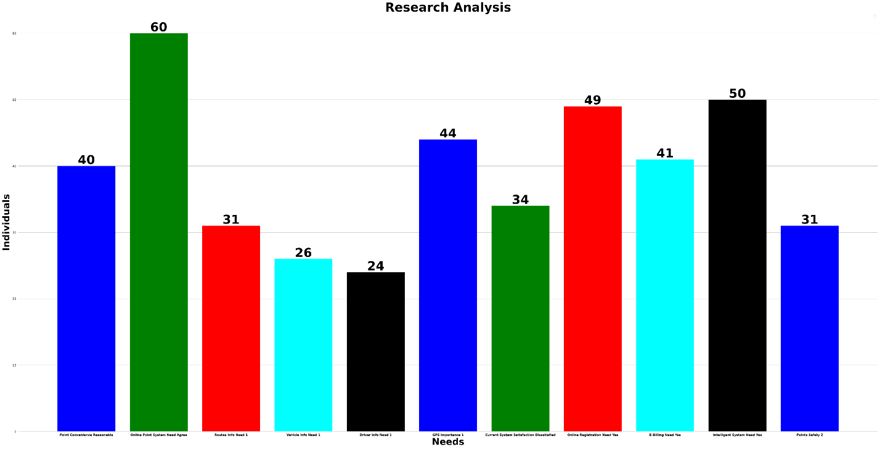

After performing a Data Analysis of the compiled data from the conducted survey by using Python Data Analysis techniques, it is therefore concluded that more than 90% supported the fact that there is an urge of Online Point System in FAST Karachi. Second, the majorly voted concern was to implement an Intelligent System of Point Service by 83% of the population. While the third most supported point was to have a facility of Online Registration for Point Services by 49 out of 64 individuals with a percentage of 81.6%. On the fourth priority, Online GPS Tracking of Points was supported by 73% of the individuals who found it extremely important that the tracking of points should be done employing GPS Sensors. Meanwhile, individuals who found it necessary to have an E-Billing Facility and who found Point Facility reasonable as compared to Public Transport are 68% and 66% respectively of the total making it the Fifth priority wise issue. The sixth most priority wise point was the dissatisfaction of the people with the current paper-based system by 56% of the individuals. Furthermore, 51.6% of the individuals found it extremely important to have first-hand information remotely of the routes on which the points will go respectively and they also consider point services safer than the public transport. Lastly, individuals who found it extremely important to know about their point drivers and the vehicle they are travelling in are 40% and 43% respectively making them the eighth-most priority wise issue to be addressed in the implementation of an Automated Point Management System in FAST Karachi.

To do the most perfect Implementation of an Automated Point Management System in FAST Karachi, it is recommended that the management should consider the following points:

* The Point Management System should be an Online System so that it can be accessed remotely irrespective of the place
* The System should be an Intelligent System utilizing Safety and Security Sensors to somehow avoid fatal accidents as well as uncertain situations to ensure the safety of passengers
* The System should be having a facility of Online Registrations for the individuals who want to avail of the Point Service to avoid long queues and manual registrations on the registration desk
* The Points should have GPS sensors to provide real-time information to the individuals who use this service as well as to the administration of the University for safety purposes
* The System should have the functionality of E-Billing to provide ease to the registered individuals through Online Funds Transfer Services so that they can pay their Point Fee online without going through the hassle of Pay Orders and Cash Payments
* The Point Management System should provide the registered users with the real-time information of the Routes their Points go to, the Point Drivers and, of the vehicles being used as Points to be aware of the sudden changes of drivers, vehicles and routes

Point Management System built following the above-stated aspects will most likely prove itself to be a worthy one and to enhance current services while providing ease to the Students, Veterans, Teaching and Non-Teaching Staff who use University Point Services as well as to the Admin Panel who administer the Point Management in FAST NUCES Karachi.